Toddlers Creed
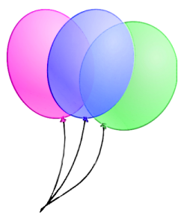

If I want it, it’s mine.
If I give it to you and change my mind later,
It’s mine.
If I can take it away from you,
It’s mine.
If I had it a little while ago,
It’s mine.
If it is mine, it will never belong to anyone else, no matter what.
If we are building something together, all the pieces are mine.
If it looks just like mine,
It is mine!
